Lesson 1
Linear Equations

sPECIFIC OBJECTIVES:

At the end of the lesson, the student is expected to be able:
- identify an equation,
- distinguish an identity equation from a conditional equation,
- solve linear equations in one variable
- solve application problems.

1.1 Equation

Definition 1.1.1 Equation

An equation is a statement that two expressions are equivalent or equal.

Example 1.1.1 Each of the following is an equation:

- 2x –4 = 7x +1
- 3(x – 4) –1 = x + 5
- 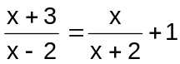
- 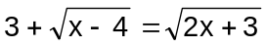

Remark:

The expression on each side of the equality sign is called a member of the equation. A variable in the unknown. A solution or root of an equation is a number that produces a true statement when substituted for the variable. The set of all roots is the solution set for the equation. At instances that an equation has no solution, such equation is called an inconsistent equation.

Definition 1.1.2 Identity Equation

An identity equation is an equation that is true for any number substituted to the variable.

Example 1.1.2 Each of the following is an identity equation:

- 3x +4 = 4 + 3x
- x(x – 3) = x² – 3x
- (x + 1)² = x² + 2x + 1

Definition 1.1.3 Conditional Equation

A conditional equation is an equation that is true only for certain values of the unknown.

Example 1.1.3 The following are conditional equations:

- 2x + 3 = x – 2
- 4x – 12 = 0
- 3(x – 2) = x + 1

Properties of Equality

For all real numbers a , b and c

- Addition Property of Equality

If a = b then a + c = b + c

- Subtraction Property of Equality

If a = b then a – c = b – c

- Multiplication Property of Equality

If a = b then a ∙ c = b ∙ c

- Division Property of Equality

If a =b then 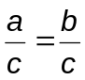

Remark:

The Properties of Equality are used to find the root or roots of an equation.

Definition 1.1.4 Equivalent Equations

Equivalent equations are equations that have the same solution sets.

Example 1.1.4 The following are equivalent equations:

a) 5x = 20 b) 5x + 2 = 22 c) x = 4

Exercise 1.1.1 Determine whether the given equation is an identity or a
conditional equation.

1. 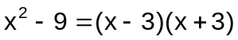
2. 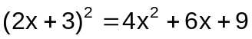
3. 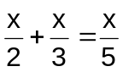
4. 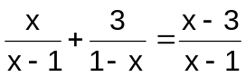
5. 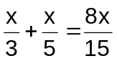

1.2 Linear Equation

Definition 1.2.1 Linear Equation

A linear equation is an equation that can be written in the form ax + b = 0, where a and b are real numbers and a is not zero.

Basic steps to solve linear equation:

- Eliminate fractions by multiplying each member of the equation by the lowest common denominator.
- Remove symbols of grouping.
- Isolate all terms containing the variable on one side of the equation and all the other terms on the opposite side. Simplify by combining like terms.
- Divide both sides of the equation by the coefficient of the variable.
- Check the solution by substituting the value of the unknown into the original equation.

Remark:

In cases wherein the variable appears under a radical sign, the radicals should first be cleared of in the equation and then follow the basics steps in solving linear equation.

Example 1.2.1 Find the solution set of the following equations:

a) 5x – 5 = 25 ans. {6}
b) 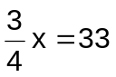 ans. {44}
c) 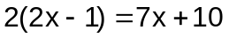 ans. {-4}
d) 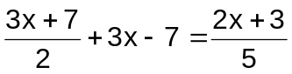 ans. {1}
e) 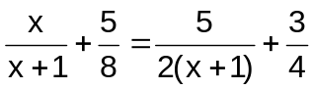 ans. {3}
f) 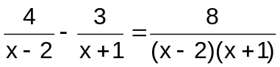 ans. {-2}
g) 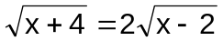 ans. {4}
h) 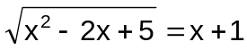 ans. {1}
i) 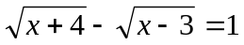 ans. {12}

Example 1.2.2 Verify if 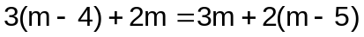is a consistent equation.

Ans. has no solution.
Thus, it is an inconsistent equation.

Definition 1.2.2 Extraneous Root

An extraneous root is a root of the derived equation but not the root of the original equation.

Example 1.2.3 Find the solution set of 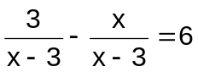.
Ans. x = 3 is an extraneous root. Hence, the solution set is { }.

Exercise 1.2.1 Find the solution of the following equations:

1. 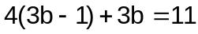
2. 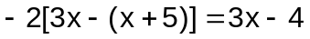
3. 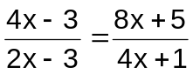
4. 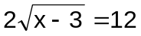
5. 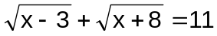

1.3 Application of Linear Equations in One Variable

Most common types of problems are:

- Number-Relation Problems
- Geometric Problems
- Money and Coin Problems
- Age Problems
- Investment Problems
Use: I = P.R where I is the interest earned, is the Principal and R is the rate.
- Mixture Problems
- Uniform Motion Problems
- Work Problems
- Clock Problems

Steps in Solving Word Problem:

- Read the problem carefully and make sure you understand it.
- Make a diagram or sketch, if possible.
- Determine the unknown quantity. Choose a letter to represent it.
- Translate quantities into algebraic symbols to form an equation.
- Solve the equation for the unknown quantity.
- Check the solution.

Example 1.3.1 One number is 20 more than the second number. If their sum is 72 , find the two numbers. ans. 26 and 46

Example 1.3.2 If a number is divided by 4, and the quotient is increased by 8, the result is 16. Find the number. ans. 32

Example 1.3.3 The sum of three numbers is 99. The first is twice the second and the third is three times the first. Find the three numbers. ans. 11, 22, 66

Example 1.3.4 The perimeter of a rectangle is 68m. The length of the rectangle is 2m more than the width. Find the length of the rectangle. ans. 18

Example 1.3.5 How many liters of 70% acid solution should be added to a 250 liter solution which contains25% acid so that the resulting mixture will be 40% acid?
ans. 125 liters

Example 1.3.6 Katrina has 84 bills consisting of P10 and P50. If the total amount of her money is P3280, how many pieces of each kind of bill does she have?
ans. 23 and 61

Example 1.3.7 A man is four years older than his wife and 5 times as old as his son. When the son was born, the age of the wife is six-seventh that of her husband’s age. Find the age of his wife. ans. 31

Example 1.3.8 Suppose Carlo and Judd can do the project together in 4 days. If Carlo can finish the project alone in 6 days, how long will it take Judd to do the project if he works alone? ans. 12 days

Example 1.3.9 On a trip Harry drove a steady speed for 3 hours. An accident slowed his speed by 30 mph for the last part of the trip. If the 190-mile trip took 4 hours, what was his speed during the first part of the trip? ans. 55 mph

Example 1.3.10 A retiree deposited a total of P15,000.00 in two different savings accounts. The interest rate on one account was 4.5%, and the interest rate on the other account was 8.0%. At the end of the first year, the interest earned on the first account was P250.00 more than the interest earned on the second account. Determine the amount deposited in each account.
ans. P11600 4.5%
P 3400 8%

Example 1.3.11 At what time after 7 o’clock will the hands of the clock be
a) together? ans. 7:38.18
b) at right angle? ans. 7:21.82
c) on a straight line? ans. 7:05.45

Exercise 1.3.1 Solve the following problems:

- How many liters of a face cream that cost P3360 per liter must be mixed with 12 liters of face cream that cost P1120 per liter to make a face cream that cost P1680 per liter?
- How many kg of corn that cost P40 per kg must be mixed with 10 kg of peanut that cost P80 per kg to make a mixture that cost P55 per kg?
- Two cyclists start from the same point and ride in opposite directions. One cyclist rides 5 mph faster than the other. In 5 hour the cyclists are 175 mile apart. Find the rate of the slower cyclist.
- A jet plane traveling at a rate of 550 mph overtakes another plane that had a 3 hour head start and is traveling at a rate of 250 mph. How far from the starting point does the jet overtake the other plane?
- An investor deposits P100,000 into two accounts. Twice the larger deposit is P25, 000 less than three times the smaller deposit. Find the amount deposited in each account.
- Mary is 24 years old. She is twice as old as Ana was when Mary was as old as Ana is now. How old is Ana?
- A girl is half as old as her brother and two years younger than her sister. The sum of the ages of the three children is 34 years. How old is each child?
- One-fourth the middle integer of three consecutive even integers is 24 less than one half the sum of the other two. Find the integers.
9. At what time after 5 o’clock will the hands of the clock be forming 120 degrees?

